**INGENIOUS CANDLE HOLDER**

**(2015CSB1116 - SHIKHAR JAISWAL)**

**(GROUP NO- 16)**

GEL 101 (PRODUCT DESIGN AND REALIZATION-1) PROJECT 6th MAY, 2016

# ABSTRACT :

This simple mechanism is powered by the stored momentum of the adjustable weight that rests on the very tip of the moveable arm. It is a relatively fool-proof solution that only relays on gravity to function.

# KEYWORDS :

* INERTIA
* GRAVITY
* PORTABLE
* INGENIOUS
* FOOL-PROOF

# INTRODUCTION :

Candles may be used to provide light or to provide "atmosphere". In most places electric light is more conveniently available than candle light. However, many people find the ever changing appearance of a candle flame to be fascinating. Candles are still widely used as table decorations in

homes, restaurants and other places where the atmosphere provided by a candle flame is desired.

Over the ages many types of candle holders have been developed. Some candle holders are primarily ornamental, others are designed to provide specific functions.

Candles have open flames. While it is possible to blow a candle flame out, it is not generally desirable to do so. Blowing a candle out can cause shortness of breath. If a person leans to close to a candle in preparation for blowing the candle out the person may be burned. Furthermore, blowing a candle out result in molten wax or other unburnt combustible materials being blown away from the candle. This is at least messy and can be dangerous. Various types of candle snuffers have been developed. The simplest candle snuffers comprise a hollow inverted cup mounted at the end of a rod. The cup can be held over a candle flame until it fills with combustion gases and the atmosphere inside the cup is no longer able to

support combustion.

There is a need for a candle holder which is capable of snuffing a candle flame after a given amount of time. There is a particular need for a candle holder which can effectively and automatically snuff a candle flame and yet is interesting to watch in operation.

Another motivation for this project is to rigorously apply knowledge gained through ***central workshop*** sessions covering all its aspects.

# DESCRIPTION :

* + *Base* : A 6mm thickness mild steel circular base(of radius 7cm) was cut from the metal sheet using 3-axis vertical *CNC* milling machine.The base should be of any insulator material.There is no particular reason for selecting the base of mild steel, it was selected because it was easily availabe in the lab.Also the reason for the circular shaped base is the fancy look.
  + *Candle holder*: A hollow square section of length 5cm was chopped using *chop saw* . A drill of 10 mm diameter was made on the two opposite faces at a height of 3 cm from the bottom . Nuts were welded on the same drilled hole , so that bolts can pass through the thread of the nut thereby making the holder adjustable for varying candle diameter.The purpose of inserting the bolts is to make the holder versatile for the various size of the candles and hence enhancing the scope of the project.There is requirement of welding the nuts at the two drilled holes because threading was not possible to the holes.
  + *Height Adjuster*: A rectangular strip of dimensions 15cmx5cmx5mm was chopped from a long metal strip using chop saw. A slot of diameter 10mm was made at the centre of the rectangular strip along the length leaving the margin of 1cm from top and bottom of the length.There was some confusion to decide the thickness of the strip because it is supposed to be welded perpendicularly at the base. If the thickness is more the weight will be more and the chances of misalignment were there.But also the advantage of the larger thickness is that it will provide larger surface area of contact to get the weld strong. Finally after sample experiment we preferred larger thickness.
  + *90 degree assembly :* We used a plane washer and thin wire of desired length and welded them on washer at an angle close to 90 degree. At the level setter wire a heavy weight bob is welded near to

its tip and on another wire, cap was fixed using adhesive. These problems are discussed in *Discussion.*

***ASSEMBLY :***

* By intuition square candle holder was welded to the circular base near one end of the diameter.
* Then the wire and the washer were welded at approximate angle of 90 degree and cap was joined via cello-tape and on another wire bob was welded thereby completing the 90 degree assembly.
* As per the measurement of 90 degree assembly ,a rectangular height adjuster was welded to the circular base at the opposite end of diameter w.r.t the square candle holder.
* The 90 degree assembly and the height adjuster were fixed via nuts and bolt.
* Thus the assembly is complete and underneath is the image of assembly.

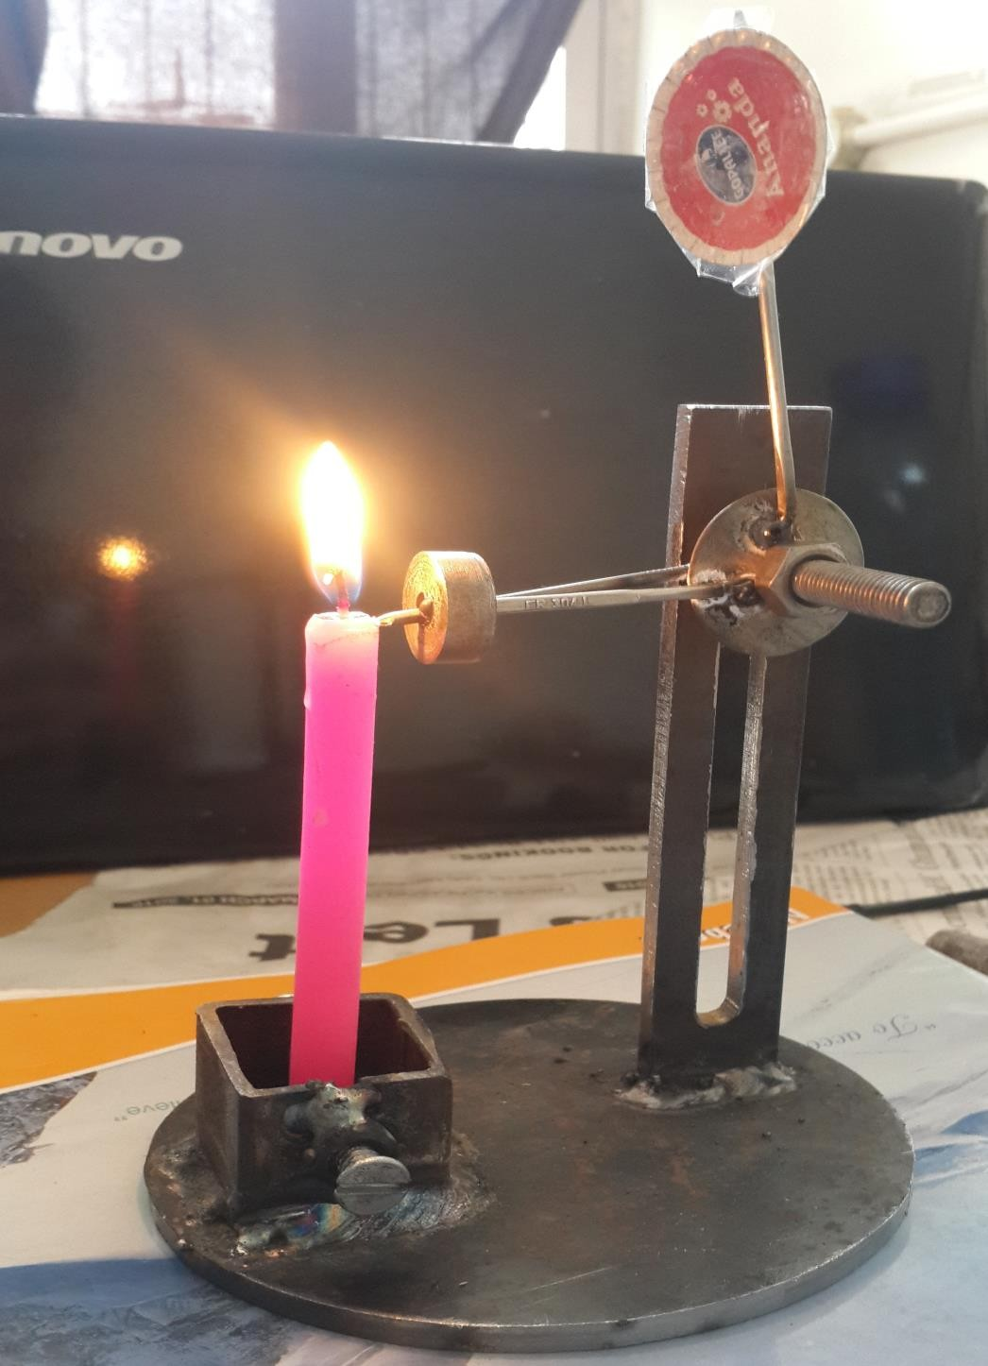

# DISCUSSION :

* + *(i)Difficulties encountered during fabrication .*
    - It was very difficult to tackle with free rotation and simultaneously fixing it to desired height for 90 degree assembly .
    - As the wires and washer were very thin , it was very difficult to weld them. Firstly the wire on which the bob was supposed to be welded was melted. So another wire was connecting the washer and the bob was passed along with the level pointing wire through the same hole of the bob.
    - Cap and wire could not be welded , therefore we have used adhesive .
* *(ii)Recommendations/Scope for future work*

•Weight reduction is possible by the light base and the height adjuster.

•The height of the height adjuster can be increased and the alternative to fix the cap and the bob to the thin wire instead of welding should be the scope for future work.

# SUMMARY :

The change in the traditional way of extinguishing candle is introduced without breathing the poisonous gases and purely using the unending force of gravity and purely mechanical timer. Also while dealing with this project we have learned how to cope with difficulties faced while transforming picture into reality.

# REFERENCES:

* [http://gizmodo.com](http://gizmodo.com/)
* [http://jimsfortheloveofhistory.blogspot.in/2011/12/simple-request-leads- to-smart-candle.html](http://jimsfortheloveofhistory.blogspot.in/2011/12/simple-request-leads-to-smart-candle.html)

**FIGURES:**